Professional skills assignment 7

Question 1.
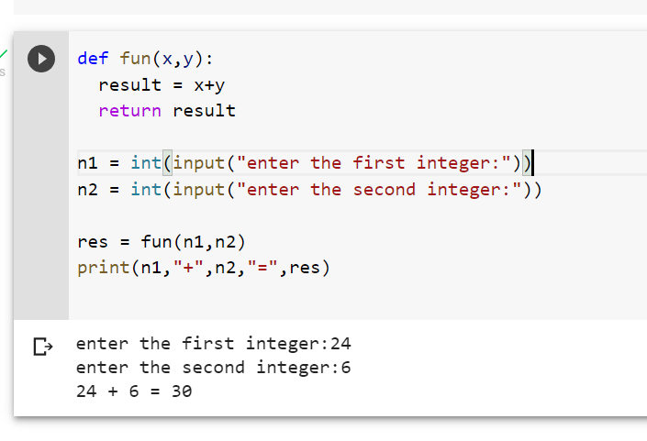

Question 2.
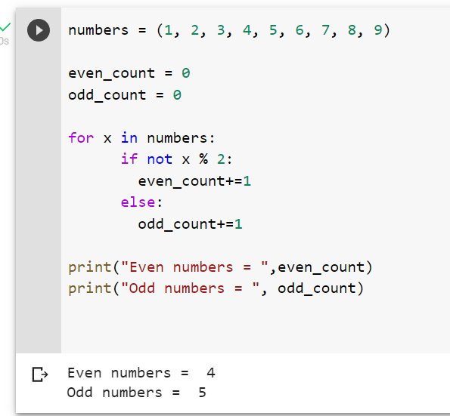

Question 3.
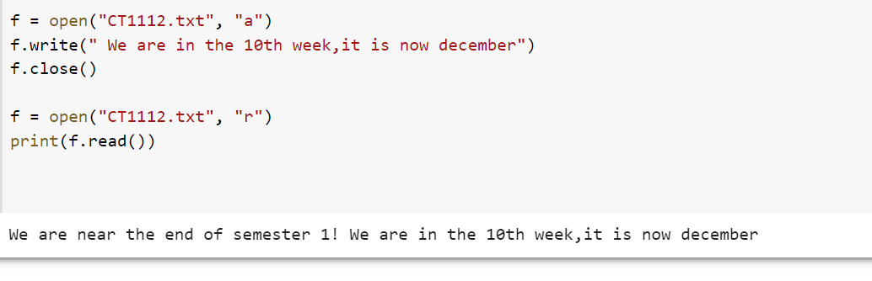
Writing to the file with “A”. a adds to the file without removing text

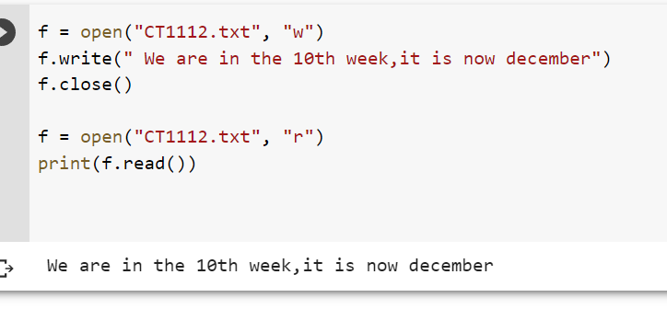
Writing to the file with ”w”, w writes to the file removing all other text that was before it

Question 4.
